Lab 3.2: Install and Configure TeamCity

This section will guide you to:

* Install and run TeamCity on your virtual machine.

This lab has 5 subsections,:

* + 1. Install TeamCity
    2. Extract the tar file
    3. Move the folder to /opt folder
    4. Run TeamCity
    5. Create an account in TeamCity

**Step 3.1.1 :**Install TeamCity.

Go to https.//www.jetbrains.com/teamcity/download, and download the tar file.

**Step 3.1.2 :** Extract the tar file.

Go to “Downloads” folder using:

cd /home/ubuntu/Downloads

Use “**ls**” to check your TeamCity file.

Then, you need to extract the file using the following command:

tar zxvf TeamCity-2018.1.3.tar.gz

Now if you use “**ls**”, you will find a directory named TeamCity.

**Step 3.1.3 :**Move the folder to **/opt** folder.

This will move TeamCity to the **/opt** file and set permissions for the user.

sudo mkdir /opt/JetBrains

sudo mv TeamCity /opt/JetBrains/TeamCity

cd /opt/JetBrains/

chmod -R 777 TeamCity

**Step 3.1.4 :**Run TeamCity.

The webserver has now started.

cd /TeamCity/bin

./teamcity-server.sh start

You can now open a browser, and open **http:x.x.x.x:8111**. Replace x.x.x.x with your IP address.

Verify that you see “TeamCity First Start” page.

Select the default database, and click on **proceed** which will initialize the components as shown in the screenshot below.

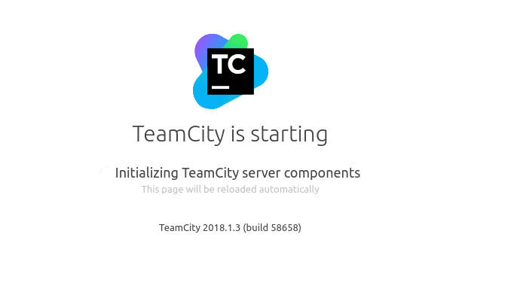

Check the **Terms and conditions,** uncheck the **send anonymous** option, and click on **Start.** You will be redirected to the **Create Account** page as shown below:

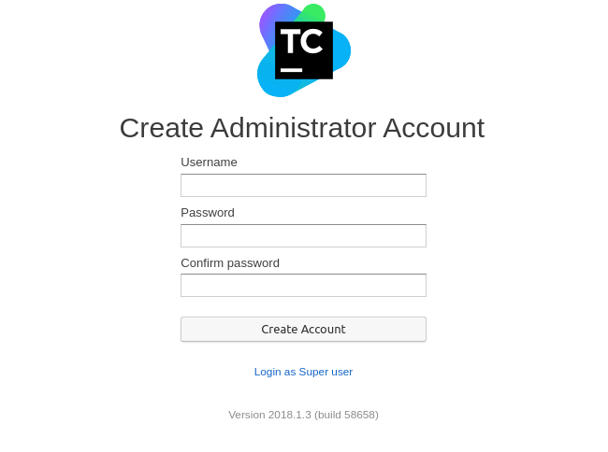

**Step 3.1.5 :** Create an account in TeamCity.

Enter the desired **username** and **password** and click on **Create account**. Enter the details and click on **Save changes**. Refer to the screenshot below:

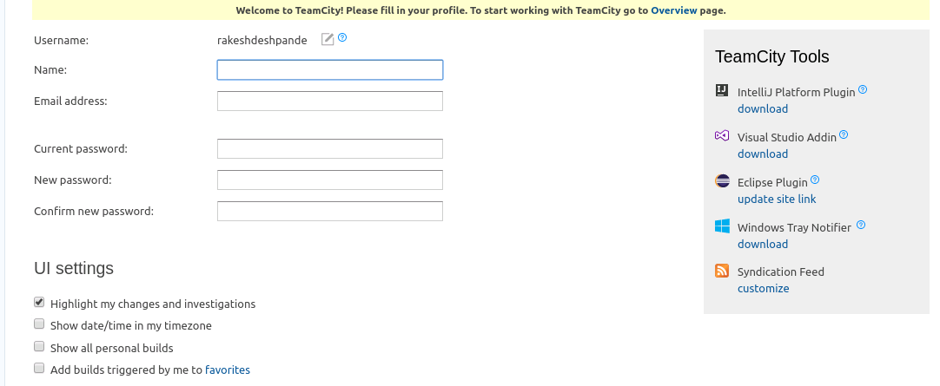

Explore the options such as **Projects**, **Changes**, **Agents**, and **Build** **Queue**.